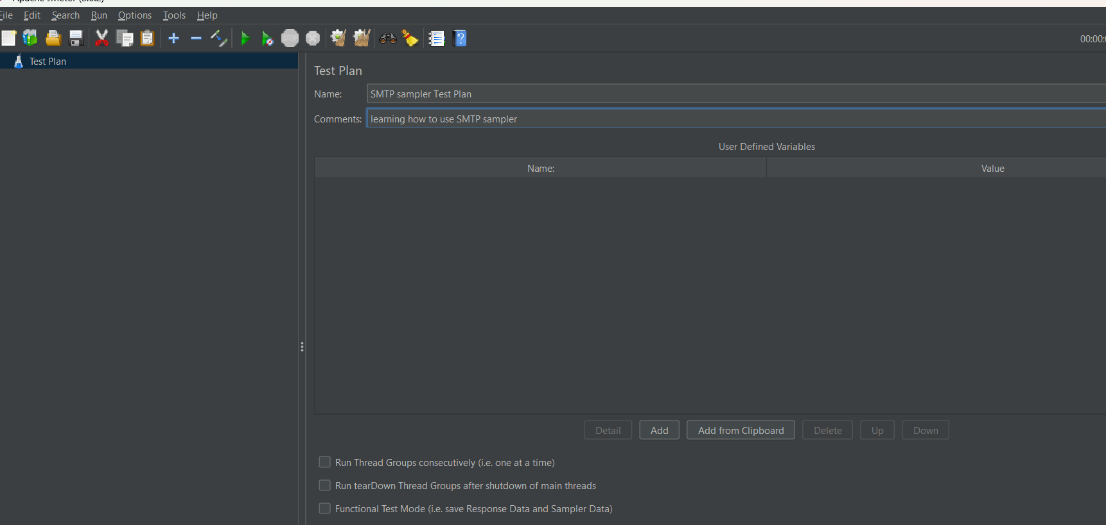SMTP Sampler will allow JMeter to send a request to a SMTP server ,the server will then send an email

step1🡪 given name to test plan as SMTP sampler test plan

step 2🡪 Right click on the test plan , then click on the add ,then click on the thread and then click on the thread user .

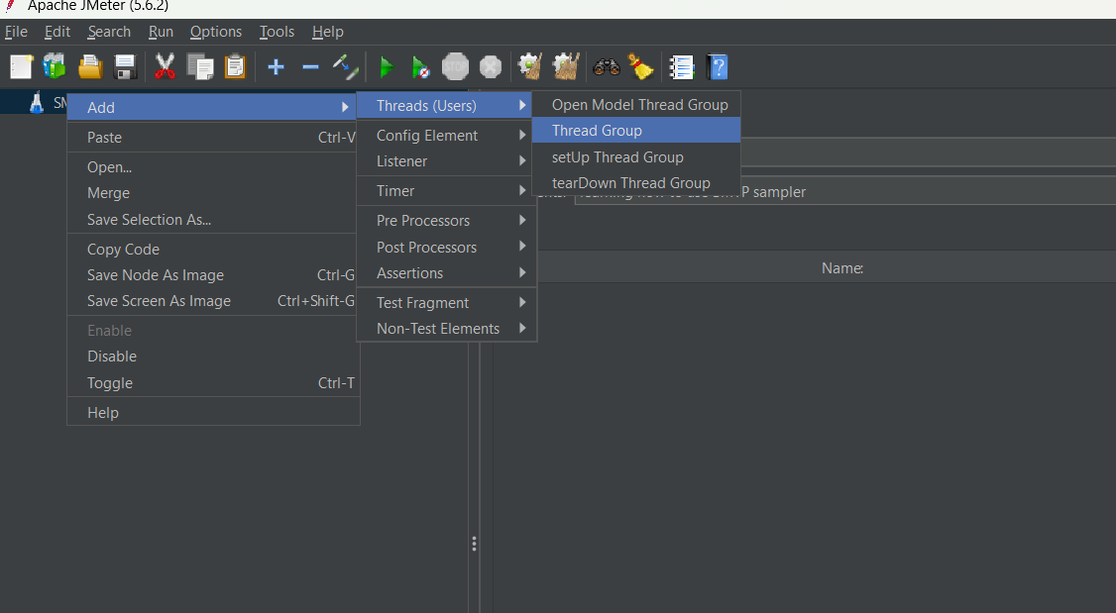Step 3🡪 Right click on the Thread plan ,click on add then click on sampler and then select the SMTP sampler to send mail.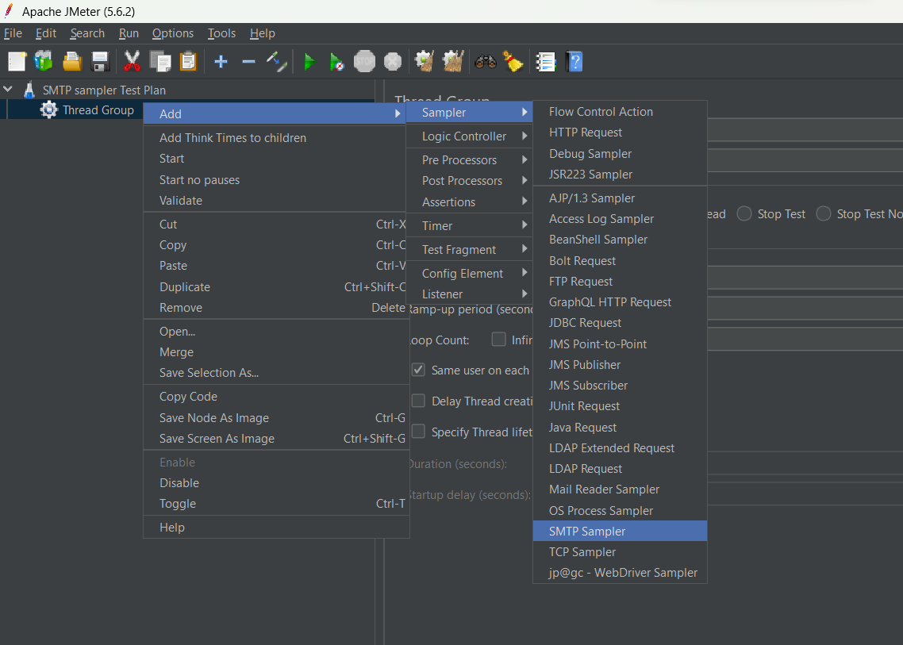

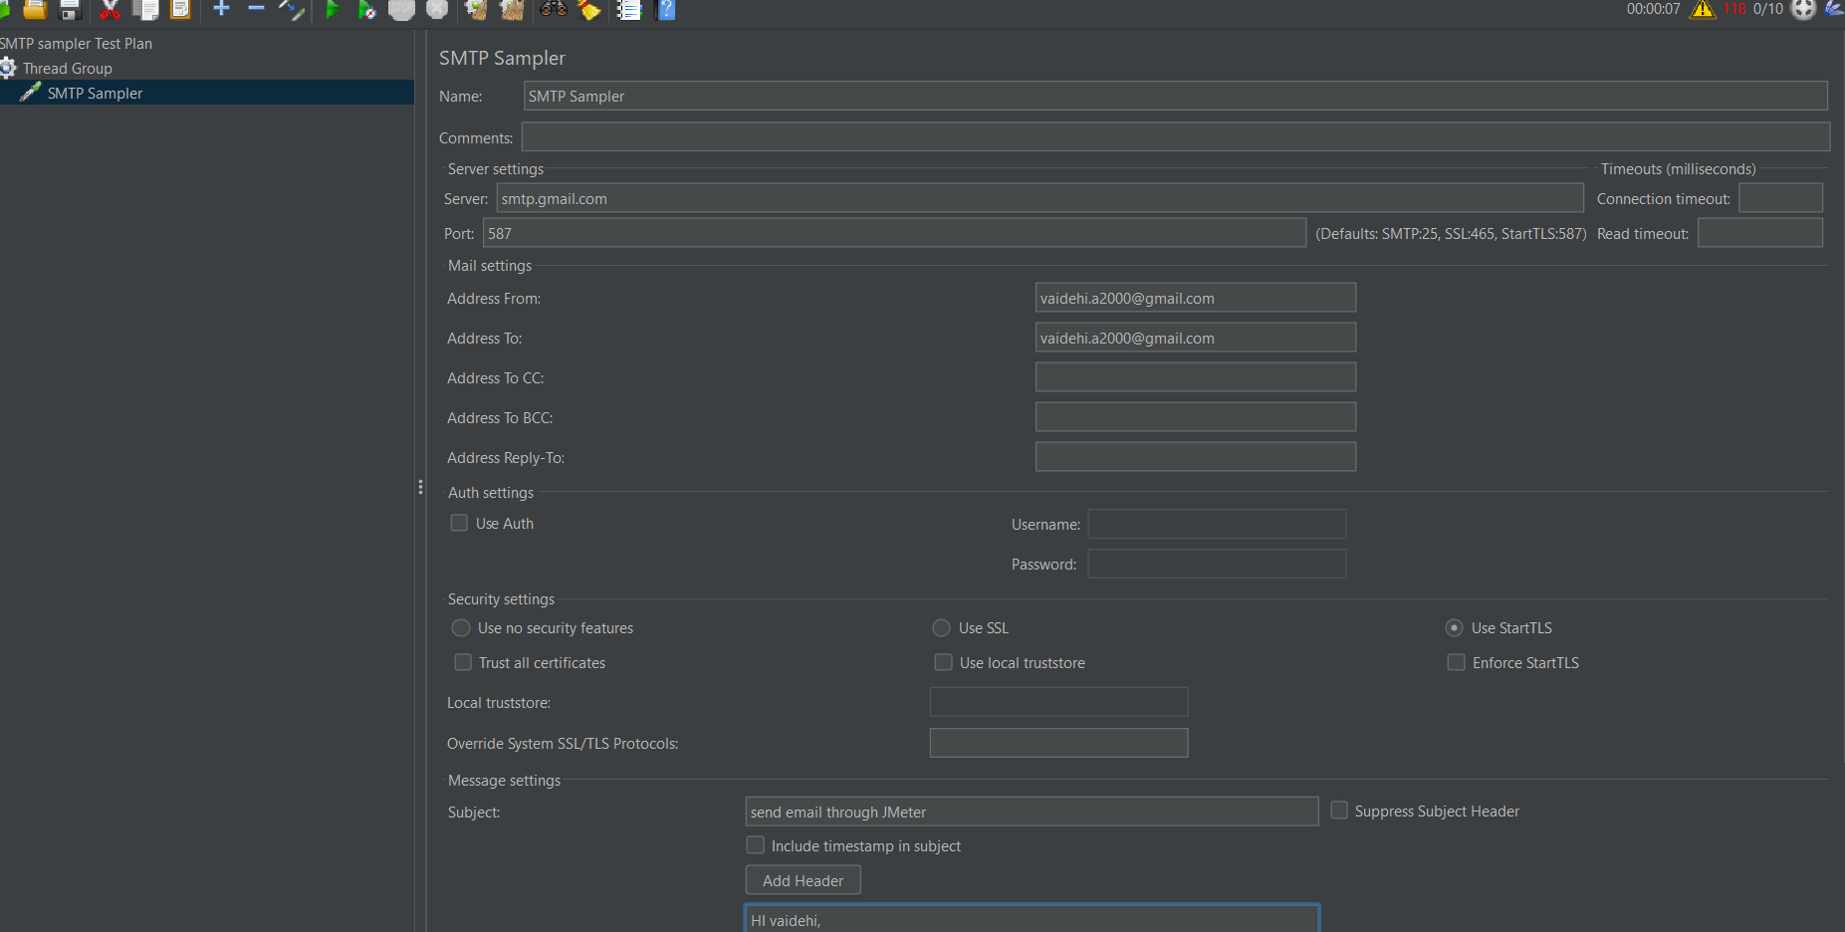Step 4🡪 In SMTP sampler in server setting ,server=smtp.gmail.com ; port =587 ;

Address from:-vaidehi.a2000@gmail.com

Address to:- vaidehi.a2000@gmail.com

Step 5🡪tick on use auth

Username –vaidehi.a2000@gmail.com

Password --\*\*\*\*\*\*\*\*\*\*\*\*\*\*

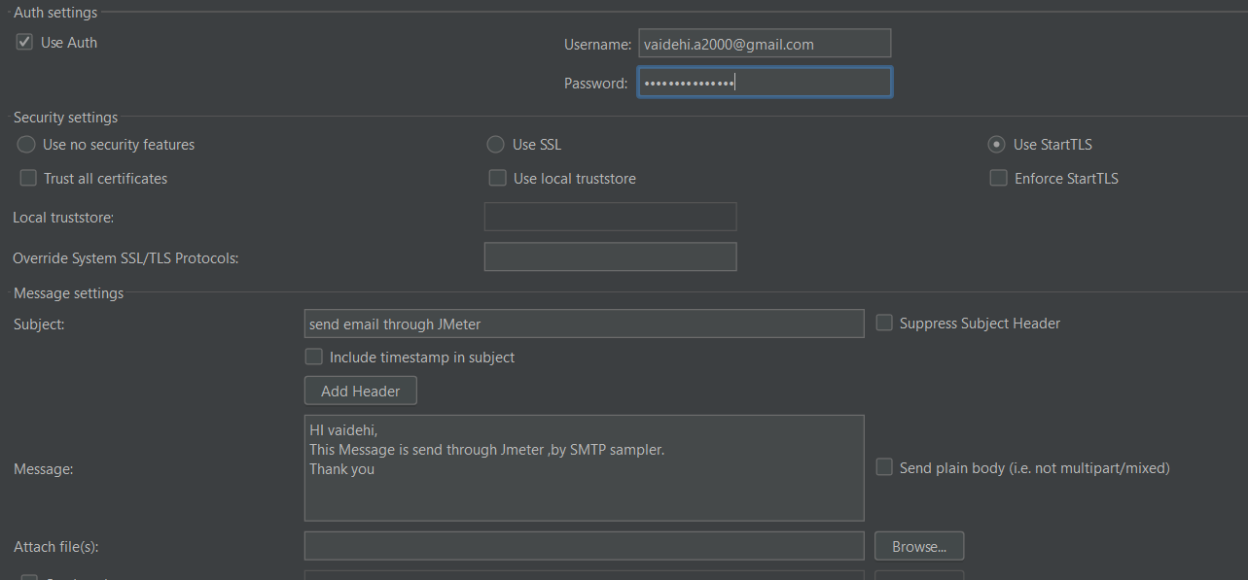

Step🡪6 Subject:-

Message:-

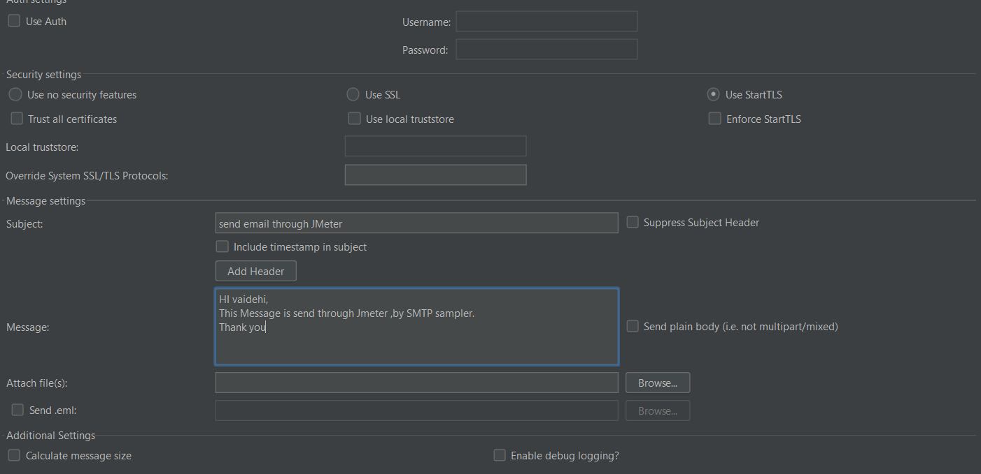

Step 🡪7 adding listner to view the result

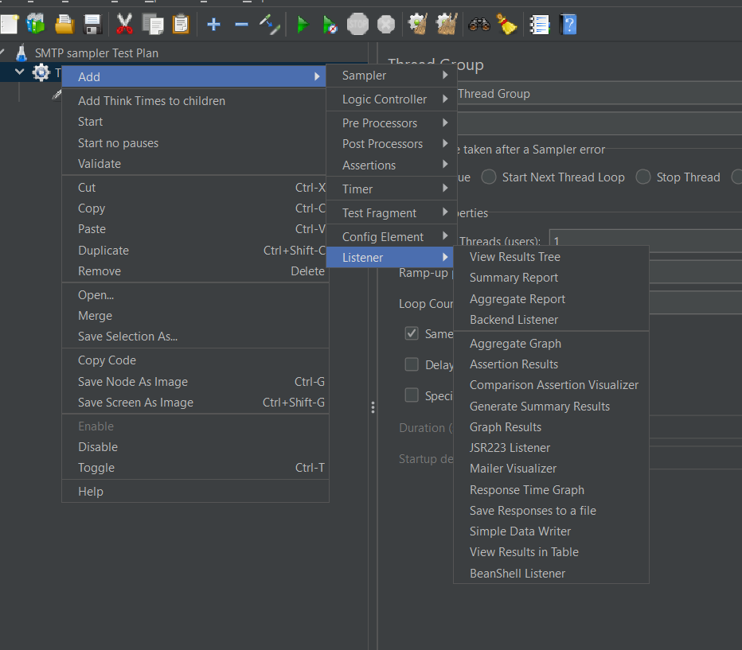

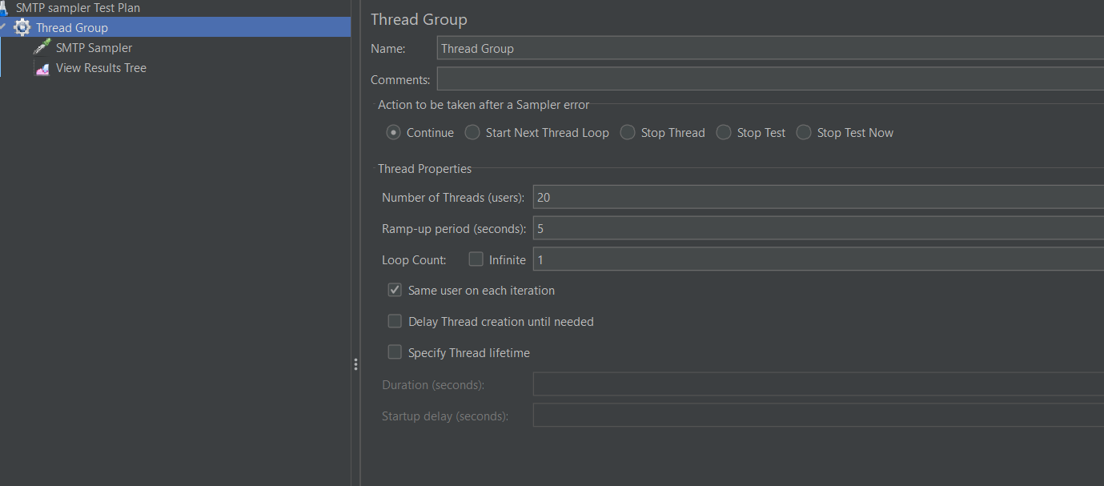

Step 8🡪SMTP Sampler fails because gmail doesn’t accept the 3rd parties ,that’s why the test plan failed.

